# Custom Doubly Linked List

## Overview

In this workshop, we are going to create another custom data structure, which has similar functionalities as the C# doubly linked list. Just like the structures from the previous workshop, our custom doubly linked list will work only with integers. It will have the following functionalities:

* **void AddFirst(int element)** **–** adds an element at the beginning of the collection
* void AddLast(int element) – adds an element at the end of the collection
* **int RemoveFirst() –** removes the element at the beginning of the collection
* **int RemoveLast() –** removes the element at the end of the collection
* **void ForEach() –** goes through the collection and executes a given action
* **int[] ToArray() –** returns the collection as an array

Feel free to implement your functionality or to write the methods by yourself.

**NOTE**: You need a StartUp class with the namespace CustomDoublyLinkedList.

### Implement the CustomDoublyLinkedList Class

**Details about the Structure**

The **doubly linked list** is a structure that resembles a list but has different functionalities. Each element in it "**knows**" about the previous one, if it is such, and the next one, again, if there is such. This is possible because the doubly linked list has **nodes** and each node has **two reference properties** pointing to other nodes and **a value property,** which contains some kind of data. By definition, the doubly linked list has a head (list start) and a tail (list end). The typical operations over a doubly linked list **add**/**remove** an element at **both of the endings** and **traverse**. If you are interested, you can find more detailed information here: <https://en.wikipedia.org/wiki/Doubly_linked_list>. This figure shows how the structure looks:

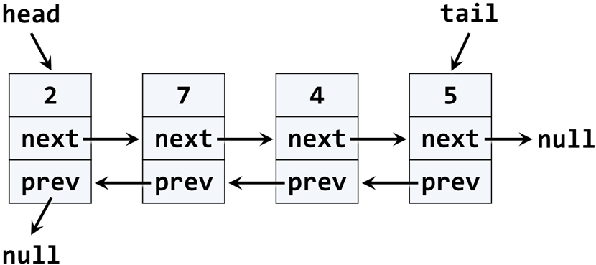

Now, that we are somewhat familiar with the doubly linked list, we can proceed to the implementation of our custom doubly linked list. We will try to implement the main functionalities, but you are free to add other ones if you are interested.

### Implementation

The first step when implementing a linked / doubly linked list is to understand that we need **two classes**:

* ListNode – a class to hold a single list node (its value + next node + previous node)
* DoublyLinkedList – a class that holds the entire list (it's head + tail + operations)

Now, let's create the **ListNode** class. It should hold a Value and a reference to its previous and next node. We can do that inside the **DoublyLinkedList** class because we will use it only internally inside it. Here is how the class should look:

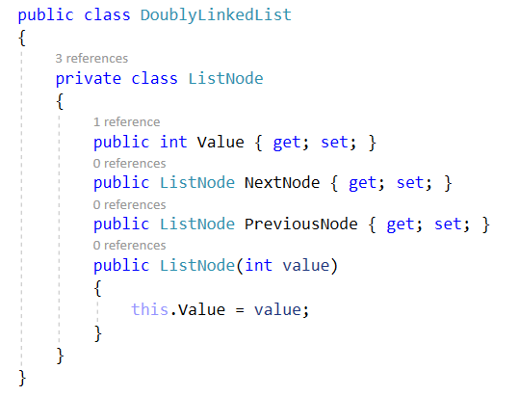

The class ListNode is called a **recursive data structure** because it references itself recursively. In this case, our nodes' **Value** property will be of type **int.** At some point throughout the next course from this module, we will be able to change that and make the structure **generic**, which means it will be able to work with any type.

### Implement Head, Tail, and Count

Now, let's define the head and tail of the doubly linked list. They will be of type **ListNode**:

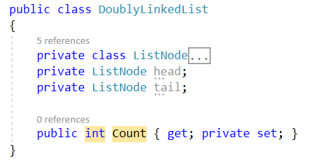

### Implement AddFirst(int) Method

Next, implement the AddFirst(element) method:

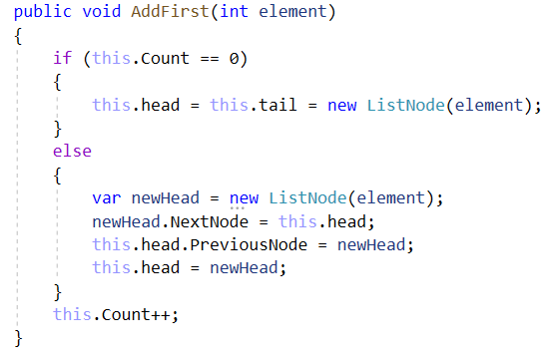

Adding an element at the beginning of the list (before its head) has **two scenarios** (considered in the above code):

* **Empty list** 🡪 add the new element as head and tail at the same time.
* **Non-empty list** 🡪 add the new element as a **new head** and redirect the **old head** as the second element, just after the new head.

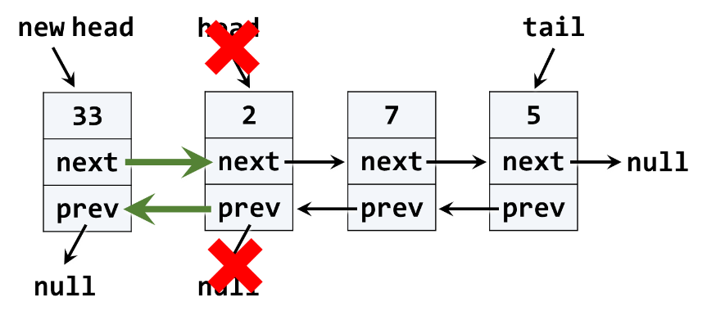

The above graphic visualizes the process of inserting a new node at the start (head) of the list. The **red** arrows denote the removed pointers from the old head. The **green** arrows denote the new pointers to the new head.

### Implement AddLast(int) Method

Next, implement the AddLast(int element) method for appending a new element as the list tail. It should be very similar to the AddFirst(int element) method. The logic inside it is the same, but we append the new element at the tail instead of at the head.

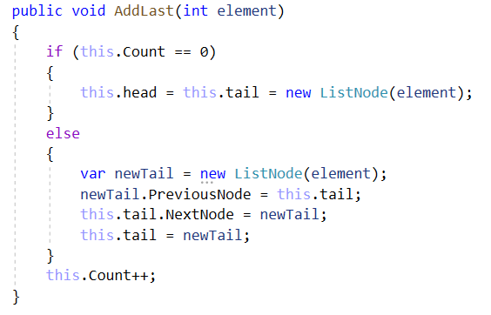

### Implement RemoveFirst() Method

Next, let's implement the method RemoveFirst() 🡪 int. It should **remove the first element** from the list and move its head to point to the second element. The removed element should be returned as a result of the method. In case of an empty list, the method should throw an exception. We have to consider the following three cases:

* **Empty list** 🡪 throw an exception.
* **Single element in the list** 🡪 make the list empty (head == tail == null).
* **Multiple elements in the list** 🡪 remove the first element and redirect the head to point to the second element (head = head.NextNode).

A sample implementation of RemoveFirst() method is given below:

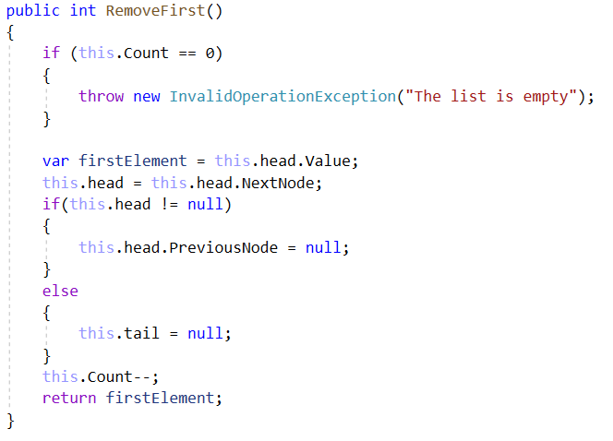

### Implement RemoveLast() Method

Next, let's implement the method RemoveLast() 🡪 int. It should **remove the last element** from the list and move its tail to point to the element before the last. It is very similar to the method RemoveFirst().

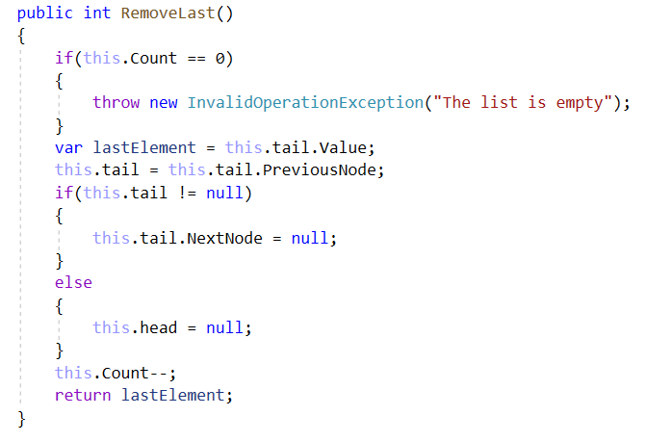

### Implement ForEach(Action) Method

We have a doubly-linked list. We can add elements to it. But we cannot see what's inside, because the list still does not have a method to traverse its elements (pass through each of them, one by one). Now let's define the ForEach(Action<int>) method. In programming, such a method is known as a ["**visitor**" pattern](https://en.wikipedia.org/wiki/Visitor_pattern). It takes as an argument a function (action) to be invoked for each of the elements of the list. The algorithm behind this method is simple: start from the head and pass to the next element until the last element is reached (its next element is null). A sample implementation is given below:

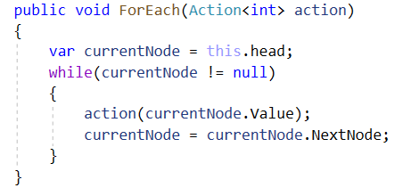

For example, if you want to print all of the elements you can use the following code:



Where **list** is **DoublyLinkedList** type object.

### Implement ToArray() Method

Now, implement the next method: ToArray() 🡪 int[]. It should copy all elements of the linked list to an array of the same size. You could use the following steps to implement this method:

* Allocate an array int[] of size this.Count.
* Pass through all elements of the list and fill them to int[0], int[1], …, int[Count-1].
* Return the array as result.

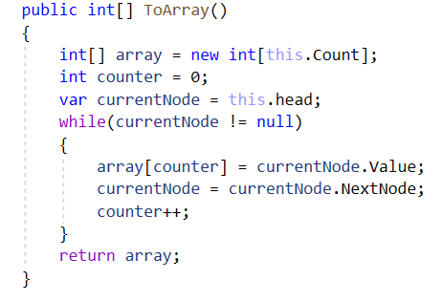

Congratulations! You have implemented your doubly linked list.